|  |  |
| --- | --- |
| Team ID | PNT2022TMID07098  **Explore AS, differentiate** |
| Project Name | Project - Nutrition Assistance Application |
| Name | Subhiksha I |
| Batch | B8-24AE |

**ASSIGNMENT 4**

**1.Pull an Image from docker hub and run it in docker playground.**

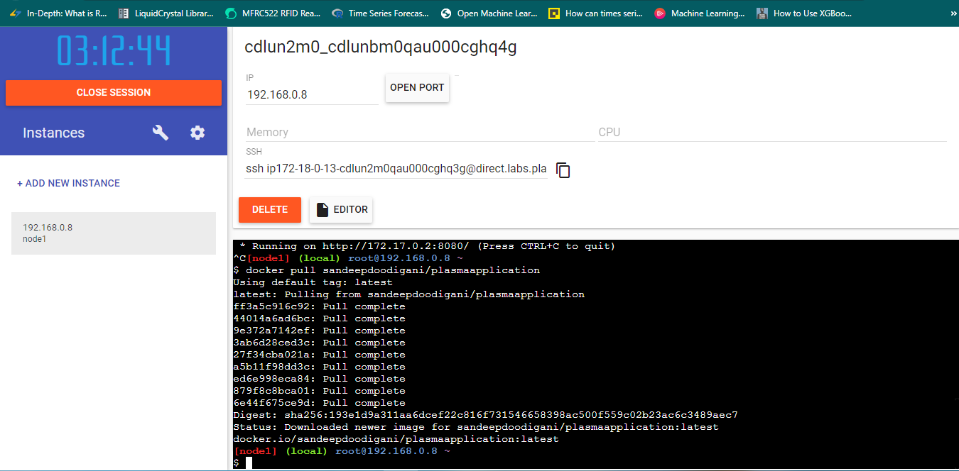

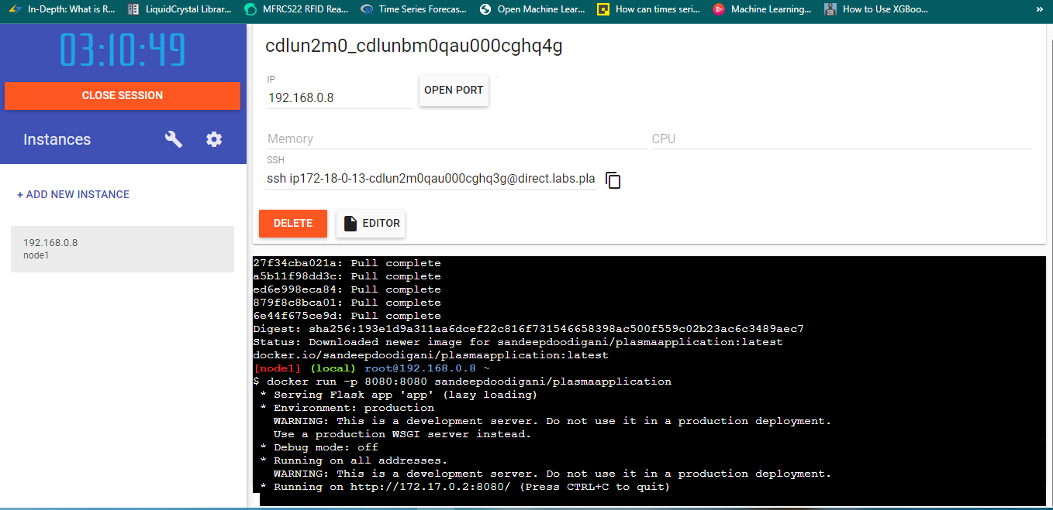

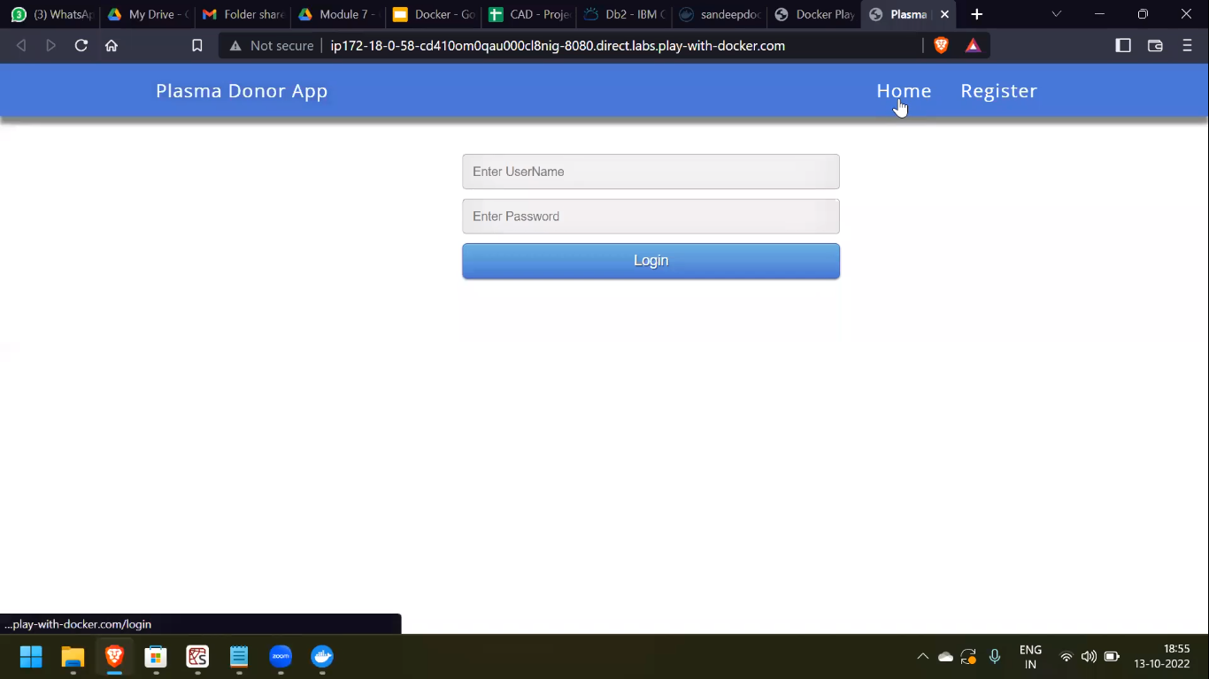

**2.Create a docker file for the job portal application and deploy it in Docker desktop application.**

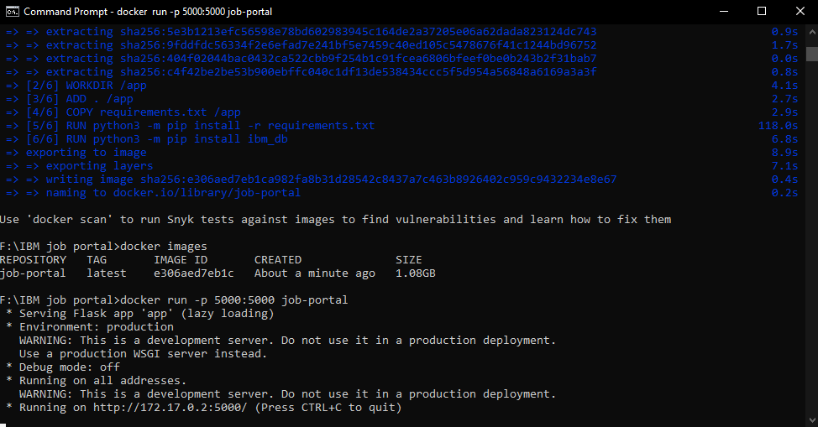

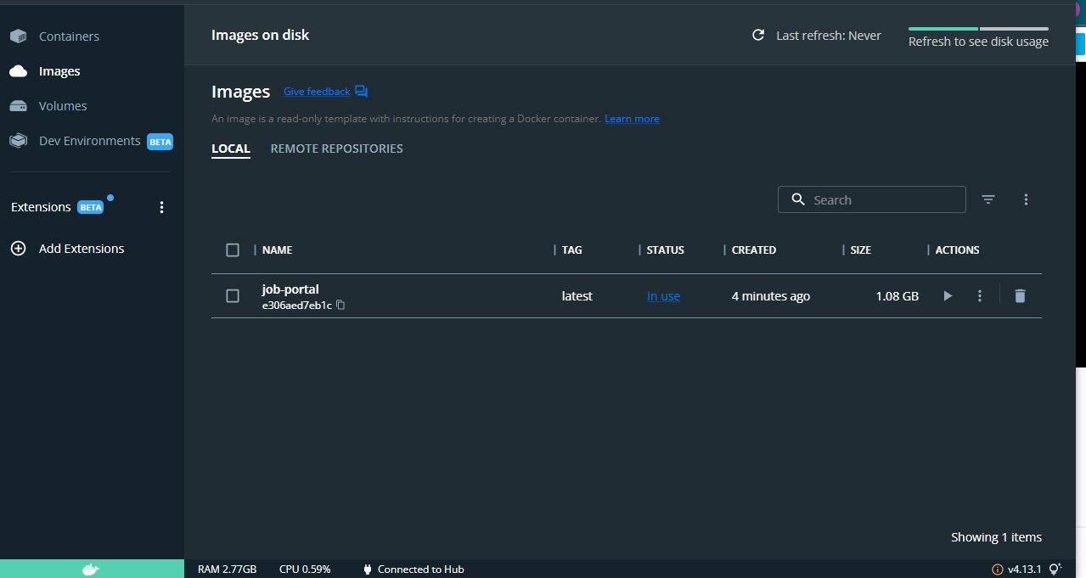

**3.Create a IBM container registry and deploy hello world app or jobportal app.**

